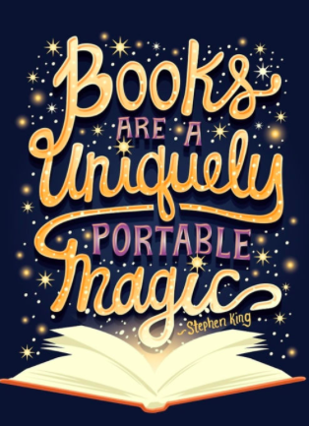

**St Paul’s Book Swap Day**

**Thursday 7th January 2021**

**Come and choose a new book to read!**

**Reading takes you to new places, so even if you can’t travel you can visit in a story.**

